Parachute Abstract / Executive Summary

Getting the Rocket to apogee is only half the battle, the recovery of the rocket is just as vital. To have a successful recovery of our Rocket we utilized a dual deployment recovery system. Dual deployment is a small parachute with a large decent velocity at apogee, and a larger parachute with a smaller decent velocity at a lower altitude. From the weight of our Rocket we could calculated the required diameter for our Main and Drogue parachutes. Considering the variables listed below (ie, Wt, CDo, So, Ve, $ρ,$ and Do) we determined acceptable decent rates for our Main and Drogue would be 5 m/s and 30 m/s respectfully. See figure 1.

Optimization of the parachute was done both experimentally and analytically. The analytical portion can be seen below with equations and figures referenced from Knacke 1. Experimentally we were able to adjust and optimize our parachute over the course of our initial 4 rockets and the Aether series. Due to the success of the Parachutes in our Aether series we will be continuing this method towards our Fiber series.

Our initial parachutes were handcrafted and consisted of a heavy plastic-nylon material and Kevlar string. These were cut to a hexagonal shape with duct tape for reinforcement on the connection between the parachute and strings. These parachutes had two significant issues during their deployment. The first was the material was very stiff and once wrapped would take up a larger than desired portion of the body tube. Secondly, the parachutes would often conform to their wrapped shape and would have difficulty opening once ejected.

Our second series of parachutes focused heavily on the material used in production. We purchased a 30’’ Nylon Parachute then modified it through the addition of a slit hole and reinforcement to the connection lines. Slit hole calculations were incorporated in our initial calculations of parachute diameter, the total Canopy surface area (So) was modeled as the difference between the complete parachute at diameter (Do) and the slit hole diameter (d). A secondary advantage to purchasing our parachute was their predetermined drag coefficient, from here calculations and experimental determinations were simplified. See figure 2.

Parachute Rate of Decent and Diameter Equations

Ve = $\sqrt{\frac{2*Wt}{CDo*So*ρ} }ft/s$

Wt = Weight of payload plus parachute assembly, lbs

CDo = Parachute drag coefficient related to So, dimensionless

So = Canopy surface area $\frac{πDo^{2}}{4} ft^{2}$

Ve = Equilibrium velocity (rate of decent) ft/s

$ρ$ = mass density of air at desired altitude, slugs/ $ft^{3}$

Do = $\sqrt{\frac{2.547*Wt}{CDo*Ve^{2}*ρ} }ft$

Do = Nominal parachute diameter

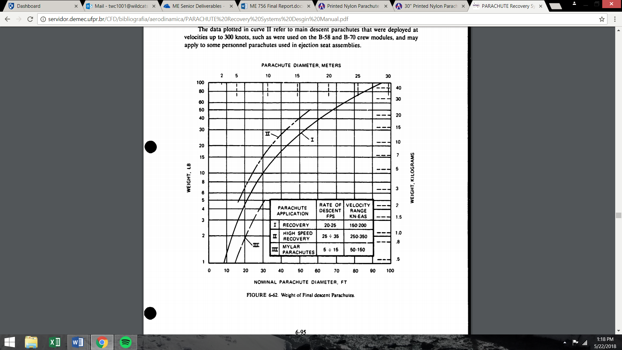

Figure 1. Parachute Diameter Chart

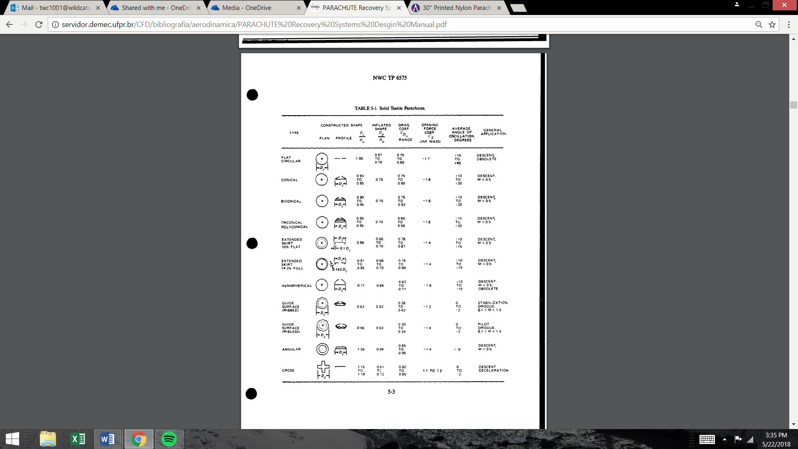

Figure 2. Parachute Drag Coefficient Chart

References

Knacke, Theo W. Parachute Recovery Systems: Design Manual. Para Publishing, 1992.